**Выполнил: Студент группы 606-12, Демьянцев Виталий Владиславович**

**Вариант 6**

|  |  |  |  |  |  |  |  |  |
| --- | --- | --- | --- | --- | --- | --- | --- | --- |
| Офис А | | | Офис Б | | | IP-адрес роутера | IP-адрес свитча | IP-адрес ПК |
| Vlan 100 | Vlan 200 | Vlan 300 | Vlan 100 | Vlan 200 | Vlan 300 |
| 17 | 31 | 75 | 17 | 31 | 60 | Последние | Предпоследние | Произвольные |

**ПАВЕЛ ГАНДОН**

**Подсеть А**

**НОВАЯ**

|  |  |  |  |  |  |  |  |  |
| --- | --- | --- | --- | --- | --- | --- | --- | --- |
| Номер подсети | Требуемый размер | Выделено адресов | Остаток свободных адресов | IP адрес подсети | Маска подсети | Префикс маски | Диапазон адресов | Широковещание |
| 300 | 75+2 | 128 | 51 | [192.168.0.0](https://ipmeter.ru/?network=192.168.0.0&mask_prefix=25) | [255.255.255.128](https://ipmeter.ru/?network=192.168.0.0&mask_prefix=25) | /25 | 192.168.0.1 - 192.168.0.126 | 192.168.0.127 |
| 200 | 31+2 | 64 | 31 | [192.168.0.128](https://ipmeter.ru/?network=192.168.0.128&mask_prefix=26) | [255.255.255.192](https://ipmeter.ru/?network=192.168.0.128&mask_prefix=26) | /26 | 192.168.0.129 - 192.168.0.190 | 192.168.0.191 |
| 100 | 17+2 | 32 | 13 | [192.168.0.192](https://ipmeter.ru/?network=192.168.0.192&mask_prefix=27) | [255.255.255.224](https://ipmeter.ru/?network=192.168.0.192&mask_prefix=27) | /27 | 192.168.0.193 - 192.168.0.222 | 192.168.0.223 |

**СТАРАЯ**

|  |  |  |  |  |  |  |  |  |
| --- | --- | --- | --- | --- | --- | --- | --- | --- |
| VLAN | Требуемый размер | Выделено адресов | Остаток свободных адресов | IP адрес подсети | Маска подсети | Префикс маски | Диапазон адресов | Широковещание |
| 300 | 90+2 | 128 | 36 | [192.168.0.0](https://ipmeter.ru/?network=192.168.0.0&mask_prefix=25) | [255.255.255.128](https://ipmeter.ru/?network=192.168.0.0&mask_prefix=25) | /25 | 192.168.0.1 - 192.168.0.126 | 192.168.0.127 |
| 200 | 25+2 | 32 | 5 | [192.168.0.128](https://ipmeter.ru/?network=192.168.0.128&mask_prefix=27) | [255.255.255.224](https://ipmeter.ru/?network=192.168.0.128&mask_prefix=27) | /27 | 192.168.0.129 - 192.168.0.158 | 192.168.0.159 |
| 100 | 14+2 | 16 | 0 | [192.168.0.160](https://ipmeter.ru/?network=192.168.0.160&mask_prefix=28) | [255.255.255.240](https://ipmeter.ru/?network=192.168.0.160&mask_prefix=28) | /28 | 192.168.0.161 - 192.168.0.174 | 192.168.0.175 |

**Подсеть Б  
НОВАЯ**

|  |  |  |  |  |  |  |  |  |
| --- | --- | --- | --- | --- | --- | --- | --- | --- |
| Номер подсети | Требуемый размер | Выделено адресов | Остаток свободных адресов | IP адрес подсети | Маска подсети | Префикс маски | Диапазон адресов | Широковещание |
| 300 | 60+2 | 64 | 2 | [172.16.0.0](https://ipmeter.ru/?network=172.16.0.0&mask_prefix=26) | [255.255.255.192](https://ipmeter.ru/?network=172.16.0.0&mask_prefix=26) | /26 | 172.16.0.1 - 172.16.0.62 | 172.16.0.63 |
| 200 | 31+2 | 64 | 31 | [172.16.0.64](https://ipmeter.ru/?network=172.16.0.64&mask_prefix=26) | [255.255.255.192](https://ipmeter.ru/?network=172.16.0.64&mask_prefix=26) | /26 | 172.16.0.65 - 172.16.0.126 | 172.16.0.127 |
| 100 | 17+2 | 32 | 13 | [172.16.0.128](https://ipmeter.ru/?network=172.16.0.128&mask_prefix=27) | [255.255.255.224](https://ipmeter.ru/?network=172.16.0.128&mask_prefix=27) | /27 | 172.16.0.129 - 172.16.0.158 | 172.16.0.159 |

**Старая**

|  |  |  |  |  |  |  |  |  |
| --- | --- | --- | --- | --- | --- | --- | --- | --- |
| VLAN | Требуемый размер | Выделено адресов | Остаток свободных адресов | IP адрес подсети | Маска подсети | Префикс маски | Диапазон адресов | Широковещание |
| 300 | 45+2 | 64 | 17 | [172.16.0.0](https://ipmeter.ru/?network=172.16.0.0&mask_prefix=26) | [255.255.255.192](https://ipmeter.ru/?network=172.16.0.0&mask_prefix=26) | /26 | 172.16.0.1 - 172.16.0.62 | 172.16.0.63 |
| 200 | 25+2 | 32 | 5 | [172.16.0.64](https://ipmeter.ru/?network=172.16.0.64&mask_prefix=27) | [255.255.255.224](https://ipmeter.ru/?network=172.16.0.64&mask_prefix=27) | /27 | 172.16.0.65 - 172.16.0.94 | 172.16.0.95 |
| 100 | 14+2 | 16 | 0 | [172.16.0.96](https://ipmeter.ru/?network=172.16.0.96&mask_prefix=28) | [255.255.255.240](https://ipmeter.ru/?network=172.16.0.96&mask_prefix=28) | /28 | 172.16.0.97 - 172.16.0.110 | 172.16.0.111 |

**Таблица устройств:**

|  |  |  |  |  |  |
| --- | --- | --- | --- | --- | --- |
| **Устройство** | **Интерфейс** | **Подключения** | **IP адрес/префикс** | **Маска** | **Шлюз по умолчанию** |
| **R1** | **G0/0/0** | **R2** | **192.168.0.161/28** | **255.255.255.240** | **-** |
|  | **G0/0/1** | **S0 A** | **192.168.0.129/27** | **255.255.255.224** | **-** |
| **R2** | **G0/0/0** | **R1** | **172.16.0.97/28** | **255.255.255.240** | **-** |
|  | **G0/0/1** | **S0 A** | **172.16.0.65/27** | **255.255.255.224** | **-** |
| **S0 A** | **Fa0/1** | **Server1** | **192.168.0.1/25** | **255.255.255.128** | **192.168.0.1** |
|  | **Fa0/2** | **Server2** | **192.168.0.1/25** | **255.255.255.128** | **192.168.0.1** |
|  | **Fa0/3** | **S1 A** | **192.168.0.1/25** | **255.255.255.128** | **192.168.0.1** |
|  | **Fa0/4** | **S1 A** | **192.168.0.1/25** | **255.255.255.128** | **192.168.0.1** |
|  | **Fa0/5** | **S2 A** | **192.168.0.1/25** | **255.255.255.128** | **192.168.0.1** |
|  | **Fa0/6** | **S2 A** | **192.168.0.1/25** | **255.255.255.128** | **192.168.0.1** |
| **S1 A** | **Fa0/3** | **PC1** | **192.168.0.1/25** | **255.255.255.128** | **192.168.0.1** |
|  | **Fa0/4** | **PC2** | **192.168.0.1/25** | **255.255.255.128** | **192.168.0.1** |
|  | **Fa0/5** | **S2 A** | **192.168.0.1/25** | **255.255.255.128** | **192.168.0.1** |
| **S2 A** | **Fa0/3** | **PC3** | **192.168.0.1/25** | **255.255.255.128** | **192.168.0.1** |
|  | **Fa0/4** | **PC4** | **192.168.0.1/25** | **255.255.255.128** | **192.168.0.1** |
| **S0 B** | **Fa0/1** | **Server3** | **172.16.0.1/26** | **255.255.255.192** | **172.16.0.1** |
|  | **Fa0/2** | **Server4** | **172.16.0.1/26** | **255.255.255.192** | **172.16.0.1** |
|  | **Fa0/3** | **S1 B** | **172.16.0.1/26** | **255.255.255.192** | **172.16.0.1** |
|  | **Fa0/4** | **S1 B** | **172.16.0.1/26** | **255.255.255.192** | **172.16.0.1** |
|  | **Fa0/5** | **S2 B** | **172.16.0.1/26** | **255.255.255.192** | **172.16.0.1** |
|  | **Fa0/6** | **S2 B** | **172.16.0.1/26** | **255.255.255.192** | **172.16.0.1** |
| **S1 B** | **Fa0/3** | **PC5** | **172.16.0.1/26** | **255.255.255.192** | **172.16.0.1** |
|  | **Fa0/4** | **PC6** | **172.16.0.1/26** | **255.255.255.192** | **172.16.0.1** |
|  | **Fa0/5** | **S2 B** | **172.16.0.1/26** | **255.255.255.192** | **172.16.0.1** |
| **S2 B** | **Fa0/3** | **PC7** | **172.16.0.1/26** | **255.255.255.192** | **172.16.0.1** |
|  | **Fa0/4** | **PC8** | **172.16.0.1/26** | **255.255.255.192** | **172.16.0.1** |
| **Server1** | **Fa0** | **S1 A** | **192.168.0.18/27** | **255.255.255.224** | **192.168.0.129** |
| **Server2** | **Fa0** | **S1 A** | **192.168.0.19/27** | **255.255.255.224** | **192.168.0.129** |
| **Server3** | **Fa0** | **S2 B** | **172.16.0.65/27** | **255.255.255.224** | **172.16.0.65** |
| **Server4** | **Fa0** | **S2 B** | **172.16.0.65/27** | **255.255.255.224** | **172.16.0.65** |
| **PC1** | **NIC** | **S1(A)** | **DHCP** | **DHCP** | **DHCP** |
| **PC2** | **NIC** | **S1(A)** | **DHCP** | **DHCP** | **DHCP** |
| **PC3** | **NIC** | **S2(A)** | **DHCP** | **DHCP** | **DHCP** |
| **PC4** | **NIC** | **S2(A)** | **DHCP** | **DHCP** | **DHCP** |
| **PC5** | **NIC** | **S1(B)** | **DHCP** | **DHCP** | **DHCP** |
| **PC6** | **NIC** | **S1(B)** | **DHCP** | **DHCP** | **DHCP** |
| **PC7** | **NIC** | **S2(B)** | **DHCP** | **DHCP** | **DHCP** |
| **PC8** | **NIC** | **S2(B)** | **DHCP** | **DHCP** | **DHCP** |

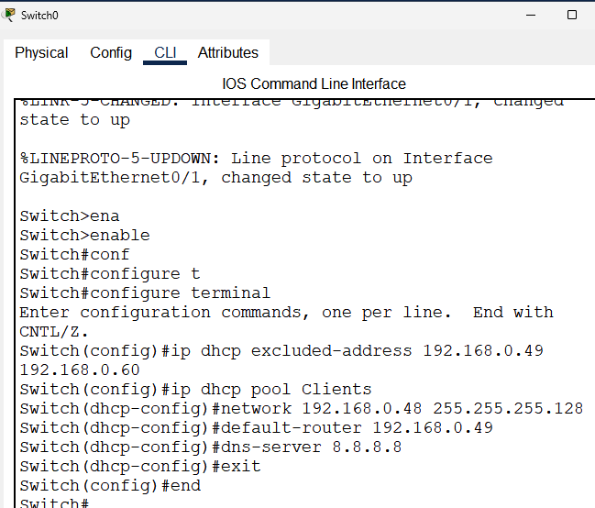

# 3

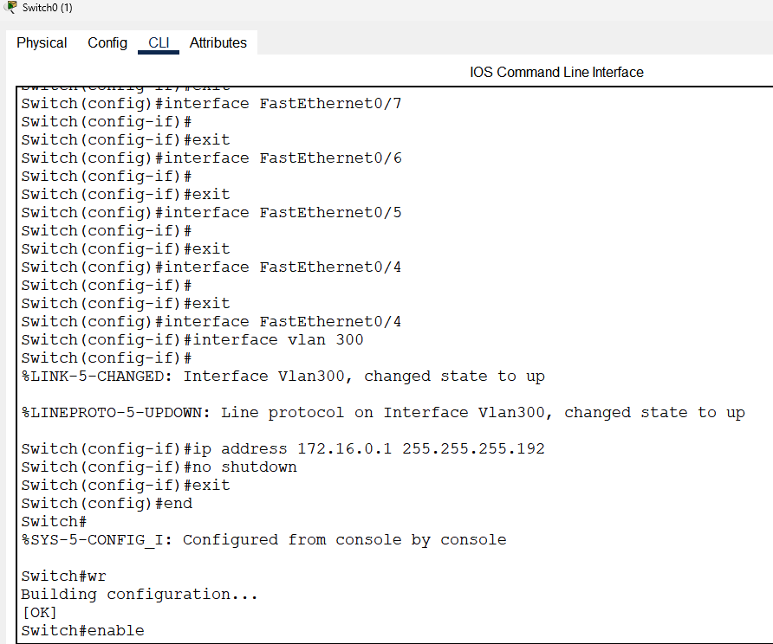

# 4

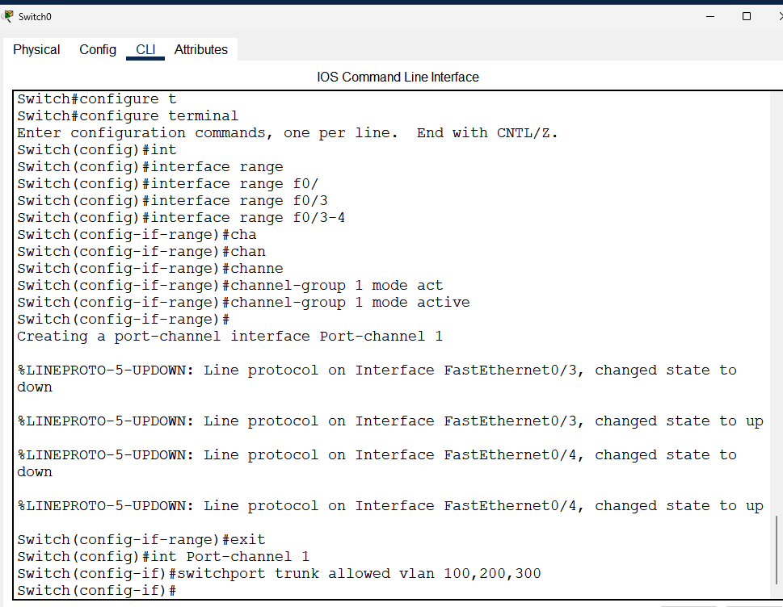

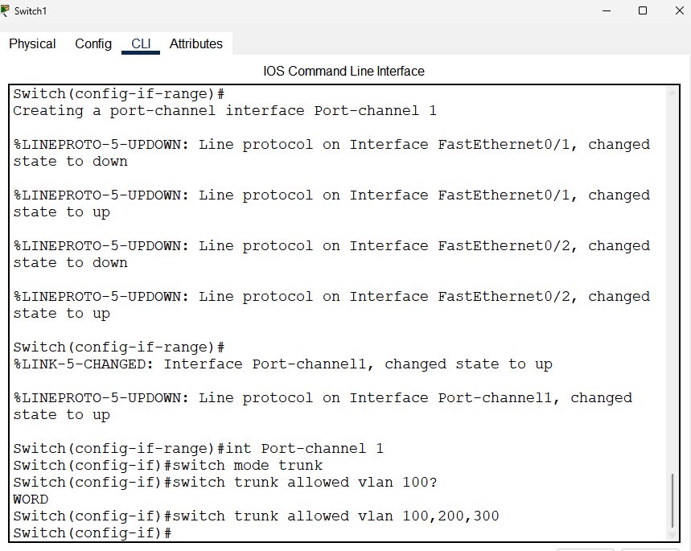

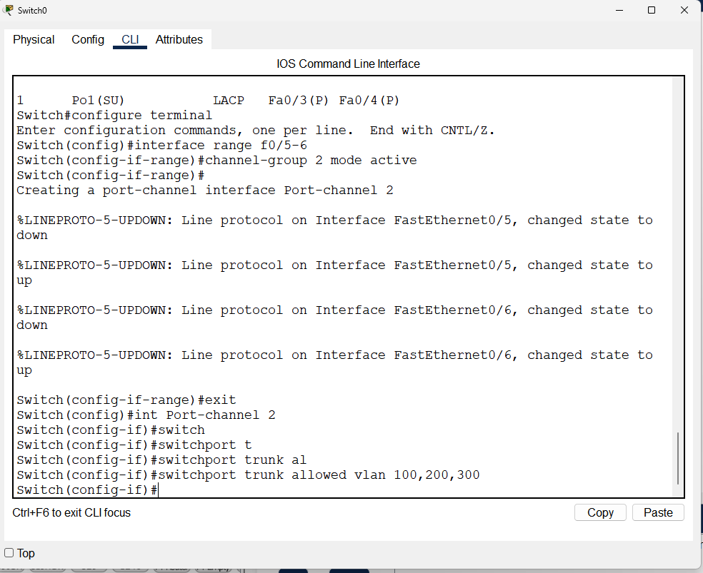

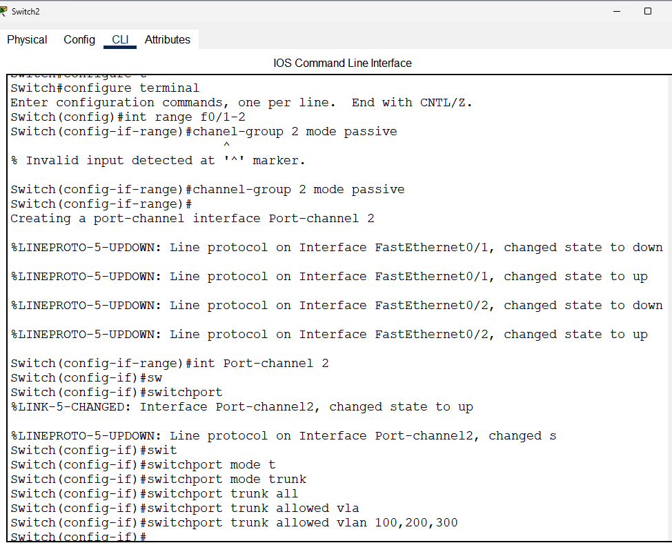

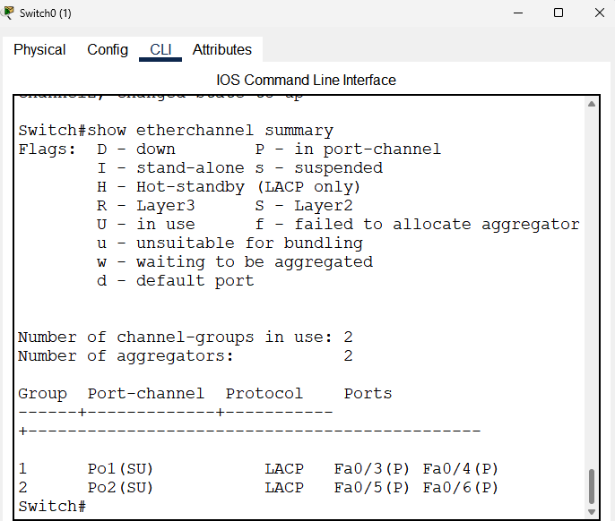

# 9

